46th Annual Medieval and Renaissance Forum

The Body in the Middle Ages and the Renaissance

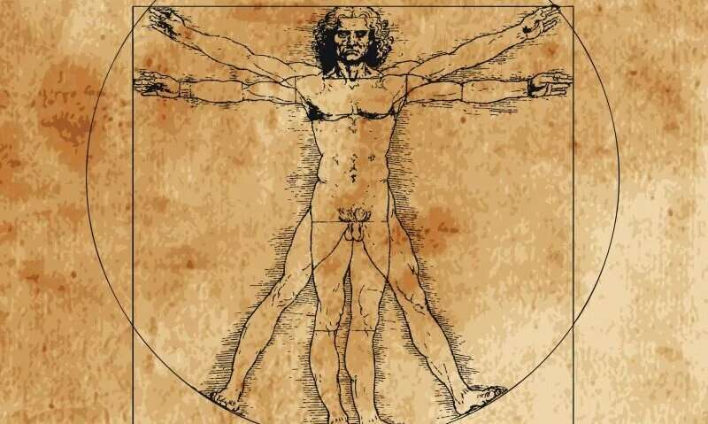

Friday, April 10 and Saturday, April 11, 2026

Keene State College, Keene, NH
Welcome

Welcome to the 46th gathering of the Medieval and Renaissance Forum and the twelfth Forum to take place at Keene State College!!!! This year, we celebrate The Body with a keynote by Dr. Colby Gordon of Bryn Mawr College on “Margaret Cavendish’s Trans Kabbalah,” a theme particularly important in the most physical and figurative of ways.

This year’s theme possesses a very special resonance in Keene today. Just a few days ago, the Board of Trustees of the University System of New Hampshire announced that President Donald Birx would continue as the President of both Keene State College and Plymouth State University. As many here know, the Forum began at Plymouth State University in 1980 before moving to Keene State College in 2015. It is especially fitting, then, that, as our institutional body comes together, the past, present, and future of the Medieval and Renaissance Forum also come together. Just as was the case twelve years ago, the President of Plymouth State University—and, of course, Keene State College—will once again initiate our proceedings.

In short, welcome to New Hampshire, welcome to Keene (and, in spirit, to Plymouth), and welcome to the Medieval and Renaissance Forum. See you at the Feast!

FRIDAY April 10, 2026

8:00 AM Coffee and Registration: Morrison 109. Registration available throughout the day.
8:45-9:15 AM Opening Ceremonies (procession will start in Morrison 109 and walk towards Mason Library Room 240)

Welcome by Meriem Pagès, Forum Director
Welcome by Dr. Donald Birx, President
and by Dr. Kirsti Sandy, Provost and Vice President for Academic Affairs
Reading of the Opening Poem
Gaudeamus Igitur, everyone

Friday Session I: 9:30 – 10:50 AM

Shakespeare
Moderator: Robert Kellerman, University of Maine at Augusta
Morrison 204

“The Anatomies of Power: Biopolitics and the Disposable Hero in Shakespeare’s
Coriolanus and the Bahman–Faramarz Episode of Ferdowsi’s Shahnameh”
Davood Khazaie, Independent Scholar

“‘Alas, Poor Ophelia, I Knew Thee Well’: Gender, Madness, and the Body in
Shakespeare’s Hamlet”
Jessica McKenzie, Seton Hall University

“Invisible Illness: Through the eyes of Shakespeare’s Romeo and Juliet”
Julie Shields, Independent Scholar

Bodies in Medieval Britain
Moderator: Christian Gobel, Assumption University
Morrison 206

“Glossing Trans Bodies in Early Medieval England”
Jonathan Davis-Secord, University of New Mexico

“Sirens, Shape-Shifters, and Saints: The Female Body in Early Irish Literature”
June-Ann Greeley, Sacred Heart University

“Julian of Norwich: A World of Body and Blood”
Jennifer May, Gordon-Conwell Theological Seminary

“Unbound: Tracing Margery Kempe's Scars”
Keri Nicole Woody, Winthrop University

Friday Session II: 11:05 – 12:25 PM

Judaism and Islam
Moderator: Meriem Pagès, Keene State College
Morrison 204

“Tell Thy Story: The Jew as Other in Pericles
Dov Rabinowitz, Seton Hall University

“Women’s Bodies in Nahmanides’ Thought”
Jessenia Rodriguez Suarez, University of Puerto Rico, Rio Piedras Campus

“Agency and Affect: Qiyān, Performative Sincerity, and the Subversion of Class”
Radman Rasti, Texas Tech University

Medieval Monasticism
Moderator: Philip O’Mara, Bridgewater College
Morrison 206

“‘Tempus fugit’: The Hours of a Benedictine Day”
Paulette Barton, Independent Scholar

“Monastic Reform and the Emergence of Medieval German Literature”
Kate DeVane Brown, Gordon-Conwell Theological Seminary

12:30 – 1:30 PM, Lunch

“Margaret Cavendish’s Trans Kabbalah”

Keynote Address by Colby Gordon

Mason Library Room 240

FRIDAY APRIL 10 1:45-3:15 PM

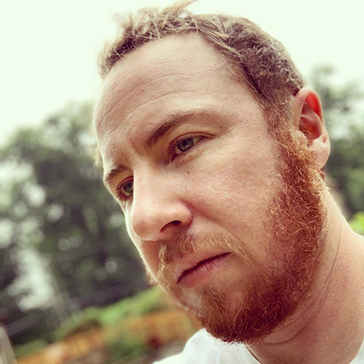

Colby Gordon is an Associate Professor in the Department of Literatures in English at Bryn Mawr College. With Simone Chess and Will Fisher, he edited a special issue of The Journal for Early Modern Cultural Studies on early modern trans studies, the first published collection to bring the conceptual vocabulary of trans studies into the analysis of gender in early modern literature and culture. In 2022, the Shakespeare Association of America named his essay "A Woman's Prick" the winner of its Innovative Article Award. His first book, Glorious Bodies: Trans Theology and Renaissance Literature, is forthcoming from the University of Chicago Press. He is currently at work on a second monograph entitled The Trans Debate and the Jewish Question.
TRADITIONAL SPINNING

A Talk and Workshop with Richena Curphey and Allison

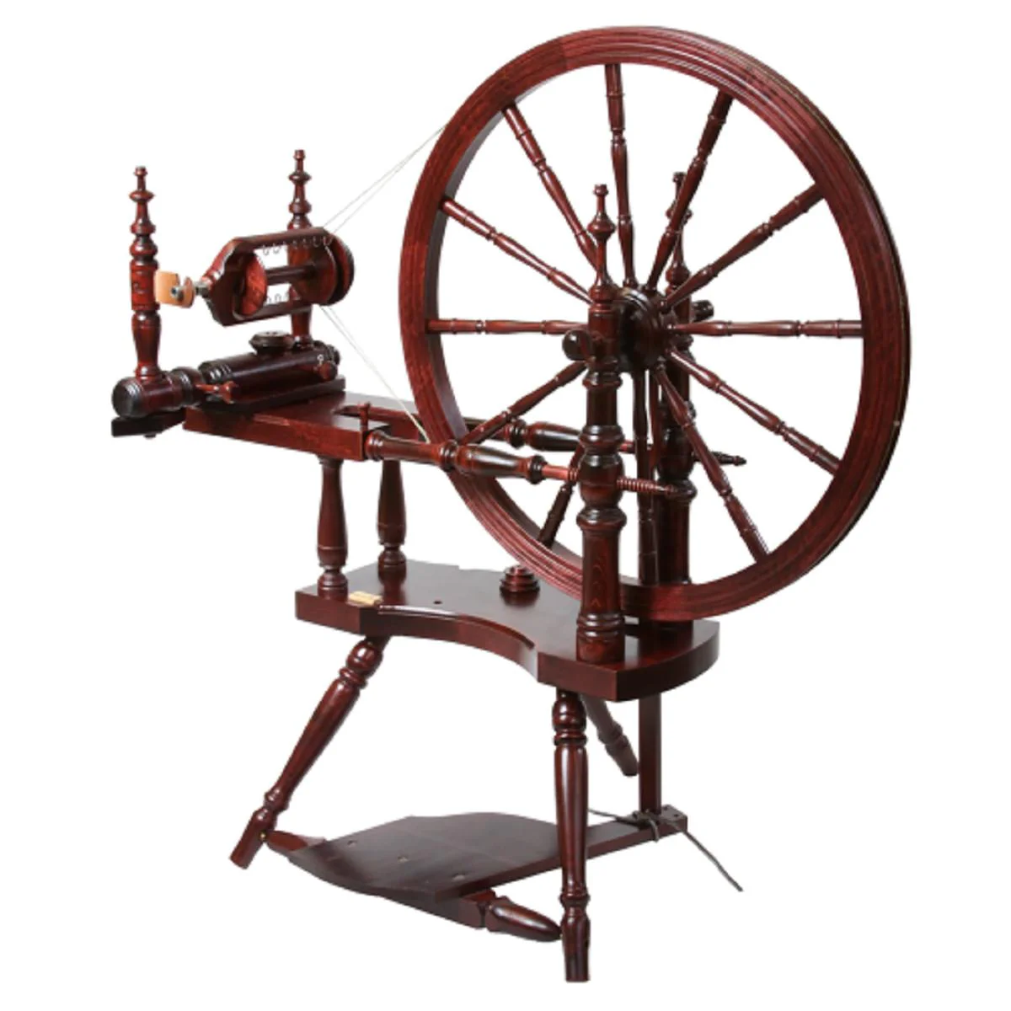

Morrison Hall 109

3:30-4:45 PM

MEDIEVAL FEAST

Alumni Center

232 Main Street

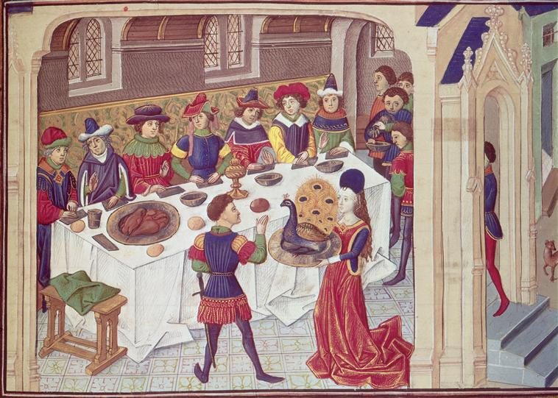

Doors open at 6:00 PM

SATURDAY APRIL 11, 2026

8:30 AM Coffee and Registration: Morrison 109. Registration available throughout the day.

Saturday Session III: 9:00 – 10:20 AM

Chaucer
Moderator: Rachael K. Warmington, Seton Hall University
Morrison 204

“Hard, Risky, and Worth It: A Dantean Ideal and a Chaucerian Responsee”
Philip F. O’Mara, Bridgewater College

“‘The Noble Monk and the Wealthy Friar: Structural Contradictions in Religious
Orders as Examined by Chaucer’s General Prologue
Brigid McGlone, Seton Hall University

Exploring Medieval and Renaissance Art
Moderator: Radman Rasti, Texas Tech University
Morrison 206

“The Illuminations of St. Hildegard of Bingen as Proto-Modern Art”
Thomas Deignan, Seton Hall University

“Gilded Devotion: The Reliquary Shrine of Elizabeth of Hungary"
Meredith Vigan-Wilbur, University of South Florida

“The Woman That Terrified Mark Twain and Titian – Many Layers of Facts and The
Mystery of “Venus of Urbino” – Untangling the Mystery”
Igor V. Chernyavskiy, Independent Scholar

Saturday Session IV: 10:35 – 11:55 AM

Renaissance, Not Shakespeare
Moderator: Jessica McKenzie, Seton Hall University
Morrison 204

“Bodily Appetites in Thomas Middleton's A Chaste Maid in Cheapside”
Robert Kellerman, University of Maine at Augusta

“‘Cursing the Time’: Queer Temporality and Reproduction in Richard Barnfield’s
The Affectionate Shepheard”
Francis Edward Nicolas III, University of Maine

“You Are What You Eat: Maize, Cannibalism, and Communion in 16th Century
Highland Guatemala”
Kendall Rander, Sweet Briar College

Medieval Romance and Its Discontents
Moderator: Mallory K. Warner, Seton Hall University
Morrison 206

“‘I Tell the Truth Without Fail or Foul’: Dissecting Gender Dynamics and Masculinity
in Marie de France’s “Lanval'”
Carter Bryant, Seton Hall University

“Reject Modernity, Embrace Tradition: How Lancelot’s Sins and Monastic Re-Birth
Influenced Art and Politics in the Victorian Era”
Megan Laterra, Seton Hall University

12:00 – 1:15 PM, Lunch

Saturday Session V: 1:30 – 2:50 PM

Getting Medieval and Renaissance, a Student Session
Moderator: Angela Jane Weisl, Seton Hall University
Morrison 204

“A Romantic Revolt: The Courtly Power Struggle in Seventeenth Century Seduction
Poetry”
Emma Cowhig, Seton Hall University

“Approaching Classics with Caution in John Milton’s Paradise Lost”
Alexa Haidacher, Seton Hall University

“Examining Maria's Significance: Complexity, Balance, and Will in Shakespeare’s
Twelfth Night”
Maxine Kunz, Seton Hall University

“Morality of Medieval Magic in Medicine”
Jacob Mudd, Seton Hall University

Medieval Philosophy
Moderator: James Howard Buckingham, Independent Scholar
Morrison 206

“Visions and Martyrs and Ecstasies, Oh My! Putting Medieval Women on Your
Philosophy Syllabus Without It Getting Too Weird”
Kelsey Boor, Boston College

“Logic or Grammar? Anselm’s Use of the Infinite Pronoun "aliquid" in Proslogion 2”
Christian Gobel, Assumption University

The Comics Get Medieval at Keene State 2026
Moderator: Michael A. Torregrossa, Bristol Community College
Morrison 202

“Cartographics: Comics, Maps, and Storytelling”
Natalia Colón Alvarez, Columbus College of Art and Design

“From Green Knight to Dark Knight: How the Medieval Romance Quest Continues in
Modern Comics”
Oisin McGillion Hughes, University of Turku

“Boys in the Wood: Embodiment and Perception from Bisclavret to Blackwater
Carlos A. González, Harvard University

“Once and Future: Comics Adaptations of Medievalisms on Screen”
Michael A. Torregrossa, Bristol Community College

Saturday Session VI: 3:00 – 4:20 PM

Medievalism
Moderator: Carter Bryant, Seton Hall University
Morrison 204

“Rethinking the Myth of Arthur: Expanding Voices in Arthurian Adaptations and
Appropriations”
Rachael K. Warmington, Seton Hall University

“Hell Is a Campus” Dark Academic Fantasy Novels and Their Use of Dante’s Inferno”
Mallory K. Warner, Seton Hall University

“Terra Incognita Australis: Finding Medieval Antarctica”
Angela Jane Weisl, Seton Hall University

Unlocking The Secrets of Beowulf
Moderator: Meriem Pagès, Keene State College
Morrison 206

“The Hidden Hoard of Beowulf—To See the Unseen and To Unsee the Seen—
Unlocking the Past with Three Keys: Spacing, Letter Runes & Echo Marks”
James Howard Buckingham, Independent Scholar

JOIN US FOR MEDIEVAL FUN WITH SIR BRIAN AND LADY EVELYN

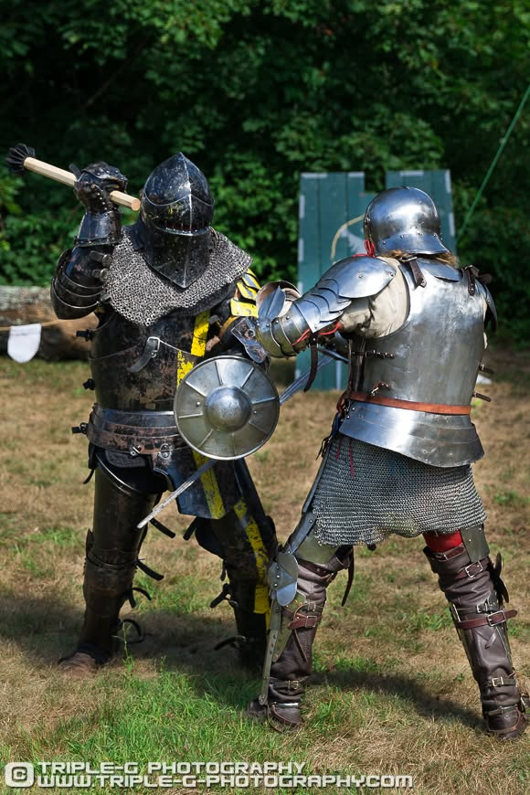

Morrison Hall 109

ALL DAY SATURDAY

The Forum Advisory Board would like to thank the following people for their hard work and support of the Forum:

Donald Birx, President, Keene State College and Plymouth State University
Kirsti Sandy, Provost, Keene State College
Karen Jennings, Dean of Faculty Development, the Liberal Arts, and Curricular Innovation
Russell Cobb, Marketing and Communications

Forum Director
Meriem Pagès, Department of English, Keene State College

Medieval and Renaissance Forum Advisory Board
Robert Kellerman, University of Maine at Augusta
Angela Jane Weisl, Seton Hall University
Mallory K. Warner, Seton Hall University

Medieval and Renaissance Forum Intern
Mary Scheidel, Keene State College Class 0f 2026

Medieval Council
Brinda Charry, Department of English, Keene State College
Nicholas Germana, Department of History, Keene State College

