Cohen Center for Holocaust and Genocide Studies
2019 Professional Development/Public Outreach Workshop

---------------------------------------------------------------------------------------------------------------------------------------
Registration Form

Name: __________________________________________________________________
Address:________________________________________________________________
City: ____________________________ State:_________ Zip: _____________
Email: ______________________________ Phone #: __________________
Vehicle:_____________________________ License Plate:______________
If an educator:
School: ________________________________________ Grades Taught: ___________
Subject(s) Taught: ________________________________________________________
_______ Dietary Restrictions:
_______ Check if OK to publish your email in workshop documents.
________________________________________________________________________________

Check workshop(s) you will be attending: $80.00 per workshop
- March 27, 2019 Teaching Holocaust & Graphic Novels Register NLT: Friday. March 15, 2019

Make checks payable to:
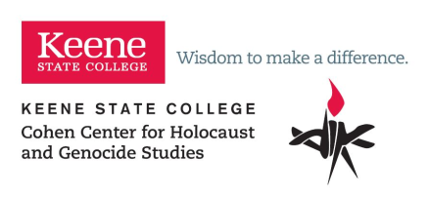

Cohen Center for Holocaust and Genocide Studies
Keene State College
229 Main Street
Keene, NH. 03435-3201
(Purchase orders will not be accepted)

